OUTBOUND BOT
AI-Powered Outbound Messaging Automation
━━━━━━━━━━━━━━━━━━━━━━
Make.com • GoHighLevel • GPT-4.1-mini

1 | Overview
This Make.com automation serves as a fully AI-driven outbound conversational bot integrated with GoHighLevel (GHL) CRM. When a contact replies to an outbound message across any channel (SMS, Live Chat, or Email), GHL fires a webhook to Make.com, which routes the message through an OpenAI Assistant (GPT-4.1-mini) to generate a contextual, human-like reply. The AI analyses the intent of each response, classifies it, extracts structured data, and writes the result back into the contact record in GHL — all in real time, with no manual intervention required.
Tools & Integrations
Tool / Integration | Details
Automation Platform | Make.com
CRM | GoHighLevel (GHL)
AI Model | OpenAI GPT-4.1-mini (via Assistants API)
Communication Channels | SMS, Live Chat (Widget), Email
Trigger | GHL Outbound Bot Webhook (instant)

2 | How It Works
The workflow is triggered instantly whenever a contact responds to an outbound message in GHL. The following sequence is executed:
Step 1 | Receive Webhook from GHL
The GHL Outbound Bot webhook fires into Make.com the moment a contact replies. The payload includes the contact ID, the incoming message body, the communication channel, the contact's first name, any custom intent data, and — if it exists — the OpenAI Thread ID from a previous conversation.
Step 2 | Route: New vs. Returning Contact
A router checks whether a Thread ID already exists on the contact record in GHL. This determines conversation continuity:
- New contact (no Thread ID): A fresh OpenAI thread is created, establishing a new conversation context from scratch.
- Returning contact (Thread ID present): The existing thread is resumed so the AI retains full conversation history and responds in context.

Step 3 | AI Response Generation
The incoming reply, along with the original outbound message, the contact's name, and the conversation intent, are passed to the OpenAI Assistant. The assistant is prompted to return a structured JSON object containing:
answer_type — Classification of the lead's response (e.g. interested, not interested, follow-up needed)
response_text — The AI-generated reply to send back to the contact
data_type — The category of extracted data (e.g. follow-up, objection, appointment)
data_value — The specific extracted value (e.g. number of days for a follow-up)

Step 4 | Contact Update in GHL
Immediately after the AI responds, all structured output is written back to the GHL contact record via custom fields: Answer Type, Response Text, Data Type, Data Value, Communication Channel, and Thread ID. GHL then picks up the updated contact record and delivers the AI-generated reply to the lead through their original channel.
Step 5 | Follow-up Handling (Returning Contacts Only)
For returning contacts, a second router checks whether the AI classified the response as requiring a follow-up. If so, an additional step generates a full conversation summary using the same OpenAI thread, which is stored in a dedicated Conversation Summary field in GHL. A follow-up date is also calculated and saved. This ensures future re-engagement has full context. If it is a regular response (not a follow-up), only the standard fields are updated.

3 | Workflow Screenshots

Make.com Scenario Overview
The Make.com scenario below illustrates the full branching logic — from the GHL webhook trigger, through the router, AI nodes, and contact update steps — including error-handling retry breaks on each node.
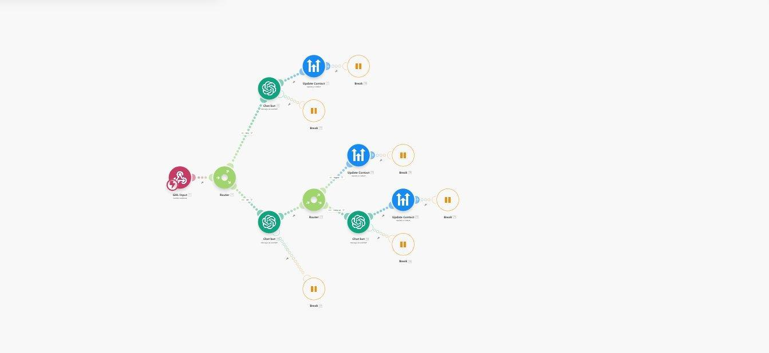
Figure 1 — Make.com scenario: GHL webhook → Router → OpenAI Assistant → GHL Contact Update
GHL Workflow — Inbound Reply Handler
The GHL workflow below is responsible for detecting when a contact replies across any supported channel. It applies a short wait, assigns the conversation to the contact owner, identifies the channel type, and routes the message to the Make.com bot via a Send to Bot action.
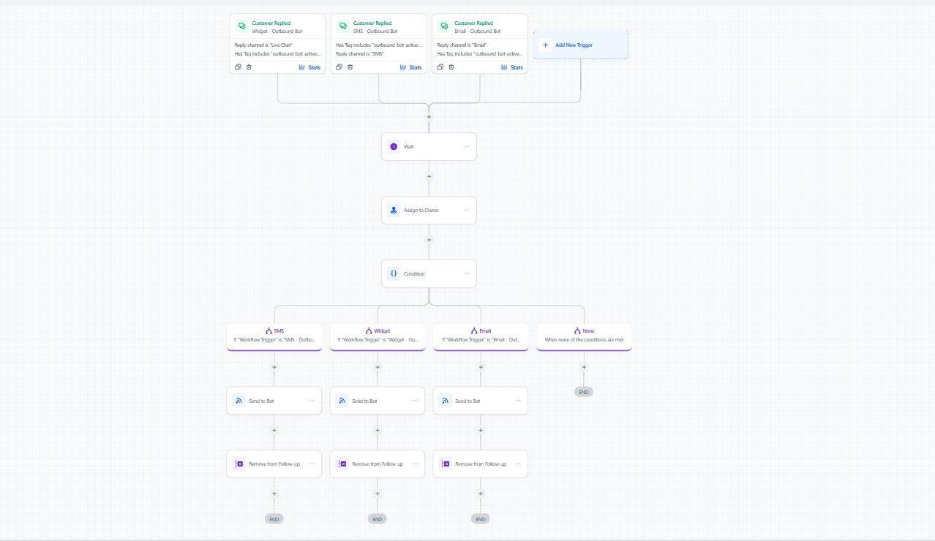
Figure 2 — GHL Workflow: Multi-channel reply detection and routing to Make.com bot
GHL Workflow — Answer Type Processing & CRM Update
This extended GHL workflow processes the AI-classified Answer Type returned from Make.com. Depending on the classification (e.g. Interested, Appointment, Objection, Follow-up, Not Interested), it applies the appropriate tags, updates opportunity stages, adds to nurture sequences, or schedules follow-ups — fully automating the post-response CRM update.
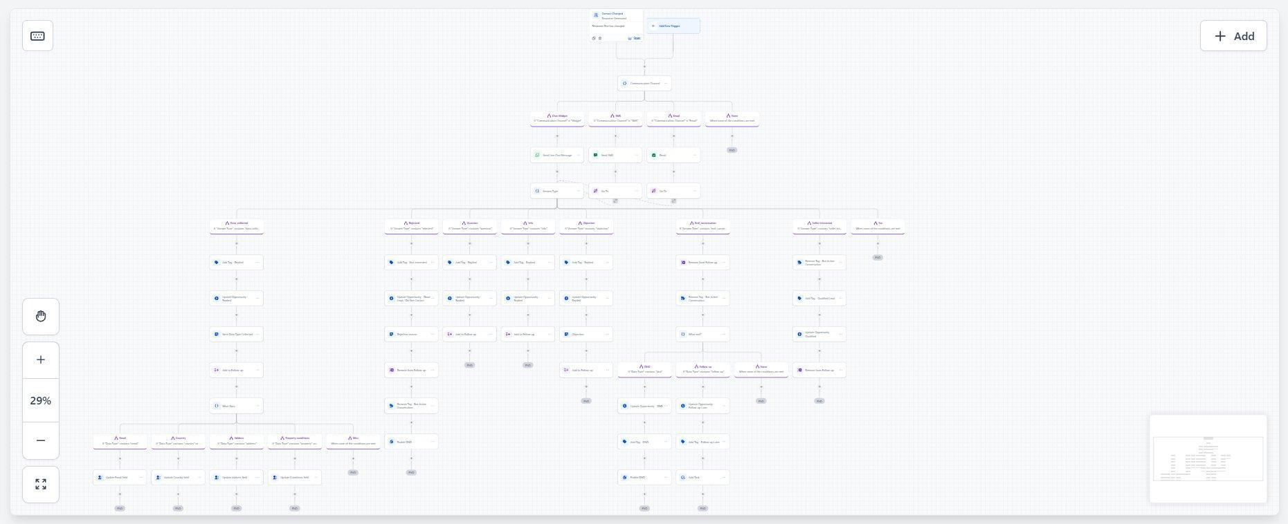
Figure 3 — GHL Workflow: Answer Type branching — tagging, opportunity updates, follow-up scheduling

4 | Challenges & How They Were Addressed

Challenge | How It Was Addressed
Stateless AI across sessions | OpenAI Thread ID is stored in GHL as a custom field. On every subsequent reply, the Thread ID is passed back to OpenAI, resuming the exact same conversation thread and preserving full context.
Multi-channel routing | The communication channel from GHL's webhook payload is passed through and used to tag and route the reply accurately across SMS, Widget, and Email.
Inconsistent or malformed AI outputs | response_format is enforced as json_object and parseJSONResponse is enabled in Make.com, ensuring downstream nodes always receive clean, machine-readable data.
API failures and transient errors | Every node calling an external API has an attached error-handler with automatic retry logic — up to 3 retries with configurable intervals — preventing silent conversation drops.
Follow-up context loss | A detailed Conversation Summary is generated via the same OpenAI thread when a follow-up is detected, and stored in GHL for use in the next outreach cycle.
New vs. returning contact differentiation | A router with a filter on the Thread ID field cleanly separates first-time replies from returning ones, branching into the appropriate processing path.

5 | Summary
This automation eliminates the need for any human to manually read, classify, or respond to outbound lead replies. The AI handles the full conversational layer, extracts structured intent data, updates the CRM, schedules follow-ups, and maintains conversation history — all within seconds of a contact's reply, across SMS, email, and live chat simultaneously. The system is resilient to API failures, stateless execution limitations, and multi-channel complexity, making it a production-ready outbound engagement engine.

✓ Zero manual intervention required for lead response handling
✓ Full conversation context preserved across sessions via Thread ID
✓ Resilient to API failures with automatic retry logic
✓ Structured JSON output for reliable CRM field updates
✓ Multi-channel support: SMS, Email, and Live Chat

End of Document

